Anatomy of a Caption-Information available at Ai Online Division http://myeclassonline.com- Intro to the Visual Arts
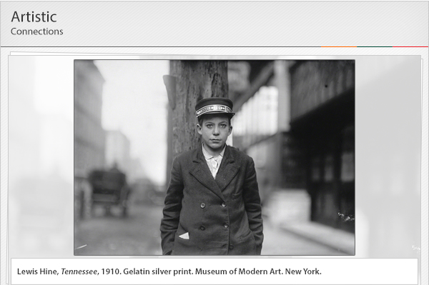
A key tool in learning how to decode and understand artwork is the caption, the information presented with your artwork in class, museums, books, and articles.
Being able to decode and understand a caption will help you identify and understand the basic information about your artwork:
The artist, if he or she is known (or the culture that produced the artwork)
The title of the artwork (if it is formally titled). Sometimes it is referred to as Untitled. (Titles are in italics)
The date when the artwork was created
The medium, i.e., materials of the artwork
The current location where the artwork is found
The size of the artwork based on its dimensions. (This information is not included in all captions).
Lewis Hine, Tennessee, 1910. Gelatin silver print. Museum of Modern Art. New York.
The photographer is Lewis Hine. The title of the photograph is Tennessee. It was taken in 1910. The type of photograph is a gelatin silver print. It can be found at the Museum of Modern Art in New York.
Museums, galleries, museum websites, and other reliable sources for artworks provide identifying information as well.

